UTS QUESTIONS

OBJECT-BASED PROGRAMMING PRACTICUM

1. Identify the following diagram class, make complete improvements and in accordance with the rules for writing the diagram class.

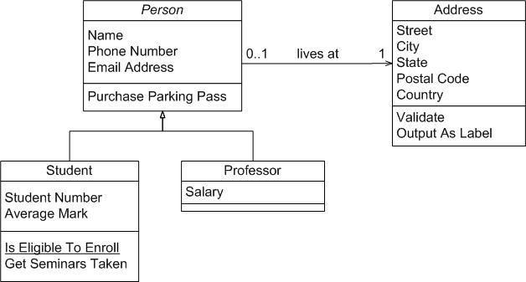

1. Create a diagram class that uses multilevel inheritance and create the program code!
2. Please identify the class diagram by providing an explanation of the concept of inheritance, the relationship between classes and the following system flow, create a program code from the following class diagram!

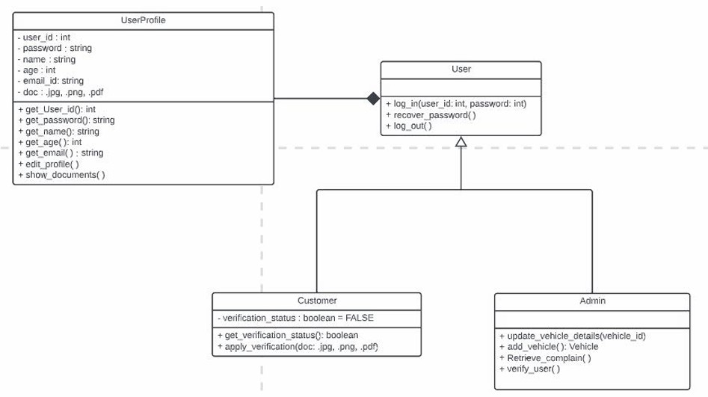

**---- Good Luck ----**